**SQL Reports Document with ScreenShots - Group 6 Project:**

**Report # 1. Offboarding Endorsement Process Duration by Department after Notice Given**

**Purpose:** Report shows process improvement

**Benefit:** Ensures the offboarding process is closing within the employee notice duration.

**Use In Business Metric:** Ensuring that all the employee's projects are completed before their last day, reducing the risk of unfinished work or delays.

**SELECT** Department_ID , **DATEDIFF**(Department_Endorsement_Date,Notice_Date) **AS** "Endorsement Duration in Days"

**FROM** A_Withdrawl_Paperwork

**GROUP** **BY** Department_ID

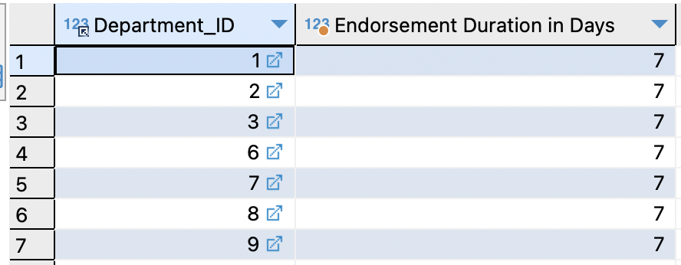

**Report # 2 - Check resigned employees salary, compared with job salary range**

**Purpose:** HR Review that Offboarded Employees Salary is within industry norm.

**Benefit:** Checks that company salaries are competitive

**Use In Business Metric:** Salary guidance to HR for employees that will be replacing the offboarded

**SELECT** e.First_Name, e.Last_Name , e.Salary ,j.Title , j.MinSalary , j.MaxSalary , **if**(e.Salary **BETWEEN** j.MinSalary **AND** j.MaxSalary, 'Salary Within Normal Range', 'Salary Not Within Normal Range')

**FROM** A_Employee e

**JOIN** A_Withdrawl_Paperwork w

**ON** (e.Employee_ID = w.Employee_ID)

**JOIN** A_Job_Title j

**ON** (e.Job_ID = j.Job_ID)

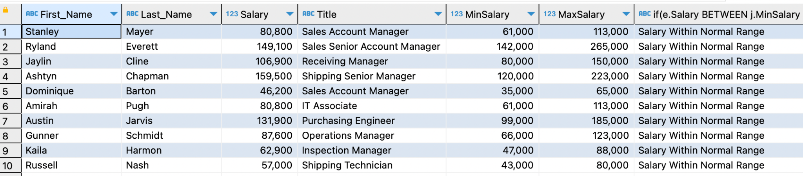

**Report # 3 - Report of Asset Status for Offboarded Employees**

**Purpose:** Ensures all items have been closed out

**Benefit:** Provides inventory of all assets of offboarded (physical, IT access, and clearance)

**Use In Business Metric:** Ensure proper close out of off boarding assets

**SELECT** ca.Asset_ID , ca.Asset_Type , co.Employee_ID, co.Ownership_End_Date

**FROM** A_Company_Asset ca

**JOIN** A_Company_Asset_Ownership co

**ON**(ca.Asset_ID=co.Asset_ID)

**JOIN** A_Withdrawl_Paperwork awp

**ON**(awp.Employee_ID = co.employee_id)

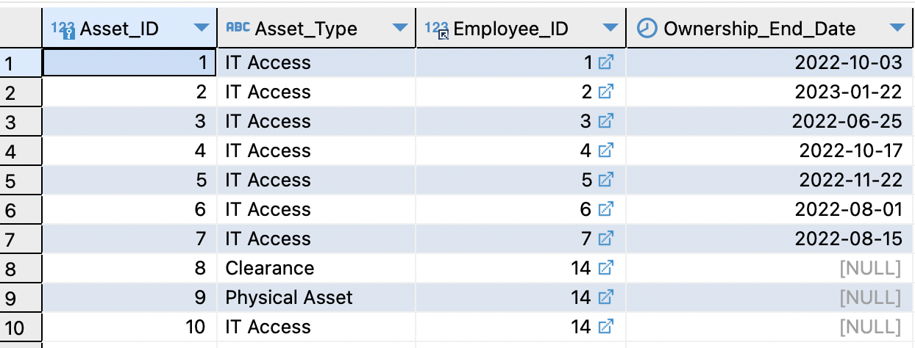

**Report # 4 - Physical Asset Utilization Report**

**Purpose:** Utilization report of all individual equipment important to the business.

**Benefit:** Useful for identifying whether there is existing stock of equipment available to be assigned to new hires or sold off or if more equipment is needed to satisfy the needs of new postings.

**Use In Business Metric:** Percent utilization of acquired personal equipment

**SELECT** P_Asset_ID,

Asset_Type,

**SUM**(**DATEDIFF**(**IF**(Ownership_End_Date **IS** **NULL**, '2023-04-07',Ownership_End_Date),Ownership_Start_Date)) **as** 'Days Issued',

**MIN**(Ownership_Start_Date) **as** 'First issue date',

**MAX**(Ownership_End_Date) **as** 'Last turn-in date',

**COUNT**(**ALL** Ownership_Start_Date) **as** 'Times issued',

**IF**(Ownership_Start_Date **is** **NULL**, 'Never Issued', **CONCAT**(

**ROUND**(100\***SUM**(**DATEDIFF**(**IF**(Ownership_End_Date **IS** **NULL**, '2023-04-07',

Ownership_End_Date), Ownership_Start_Date)) /

**DATEDIFF**('2023-04-07',Purchase_Date)

),'%')

) **as** 'Utilization',

Purchase_Date,

**FLOOR**(**DATEDIFF**('2023-04-07',Purchase_Date)/365) **as** 'Years Owned',

**MOD**(**DATEDIFF**('2023-04-07',Purchase_Date),365) **as** 'Days Owned'

**FROM** A_Company_Asset a **RIGHT** **JOIN** A_Physical_Company_Asset p **on** a.Asset_ID = p.P_Asset_ID

**LEFT** **JOIN** A_Company_Asset_Ownership o **on** o.Asset_ID = a.Asset_ID

**GROUP** **BY** P_Asset_ID

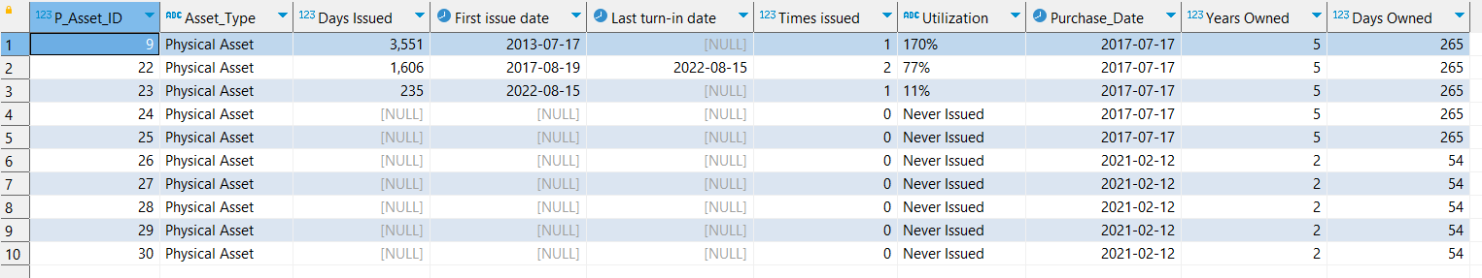

**Report # 5 - Report of All Assets Distributed by Department**

**Purpose:** For Annual Review by managers of equipment condition and whether it is still required to be issued/granted to that employee.

**Benefit:** Annual review will allow managers to shut off access or require equipment turn in when no longer needed. This reduces the amount of equipment to turn in/access to shut off when employee resigns. This also reduces the need to purchase more equipment for new hires when existing hires no longer need their equipment.

**Use In Business Metric:** Average tracked accesses and physical assets per employee as a measure of system complexity and maintenance overhead.

**SELECT** aca.Asset_ID,

aca.Asset_Type,

(**CASE** **WHEN** aca.Asset_Type = 'IT Asset' **THEN** **CONCAT**(aiaca.Access_Type,' ', aiaca.Location)

**WHEN** aca.Asset_Type = 'Clearance' **THEN** Clearance_Type

**ELSE** Asset_Type **END**) **as** 'Description',

**CONCAT**(ae.First_Name, ' ', ae.Last_Name) **as** 'Employee',

ad.Name **as** 'Department',

Ownership_Start_Date

**FROM** A_Company_Asset_Ownership acao **LEFT** **JOIN** A_Company_Asset aca **on** acao.Asset_ID = aca.Asset_ID

**LEFT** **JOIN** A_Clearance_Company_Asset acca **on** acca.C_Asset_ID = aca.Asset_ID

**LEFT** **JOIN** A_IT_Access_Company_Asset aiaca **on** aiaca.IT_Asset_ID = aca.Asset_ID

**LEFT** **JOIN** A_Employee ae **on** acao.Employee_ID = ae.Employee_ID

**LEFT** **JOIN** A_Department ad **on** ae.Department_ID = ad.Department_ID

**WHERE** Ownership_End_Date **IS** **NULL**

**ORDER** **BY** ad.Name, ae.First_Name, ae.Last_Name

